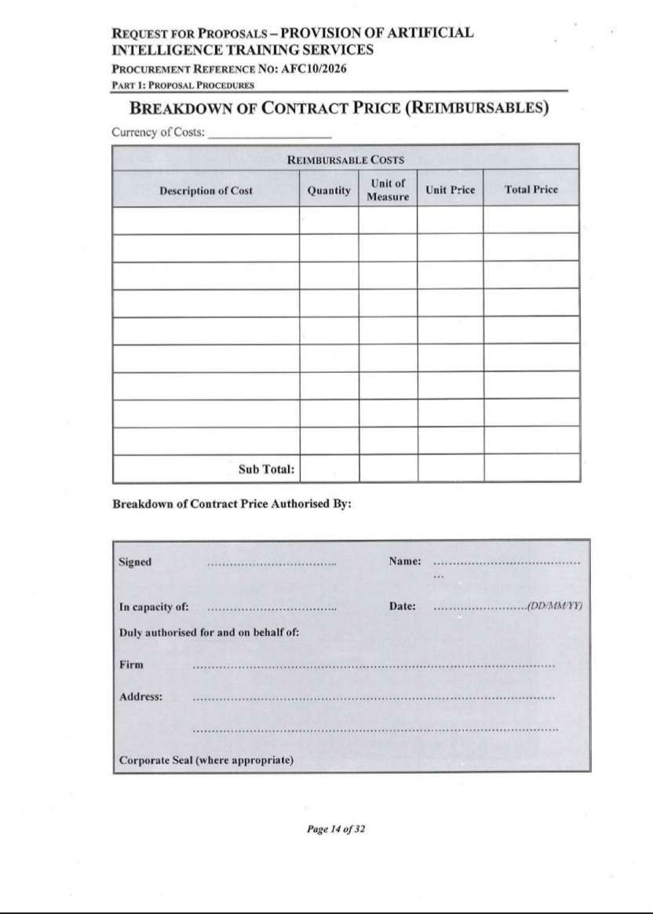
Artificial Intelligence Initiative Africa aiiaaiia_alt_logo_v5-removebg-preview_alt_logo_v5-removebg-preview
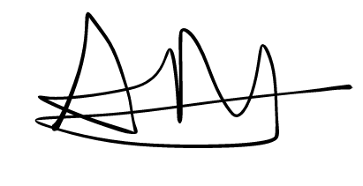
Arthur Magaya
